KS1 – English and Reading(Please continue to read on a daily basis)  www.phonicsbloom.com for daily phonic practise. Phase 3, 4, 5 and 6 | www.bbcbitesize.ks1.poems  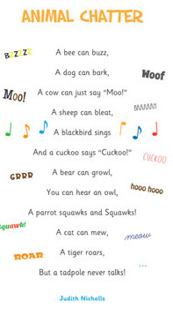  Animal Chatter By Judith Nicholls.  Can you  Write your  Own Animal  Chatter  Poem? | Re write the story of The Three Little Pigs replacing the pigs and wolf with your own new animal characters. | 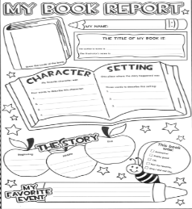  Book Review of your favourite book. www.printables.com/free-printable-childrens-book-templates/
1 .Create bad and good characters on a top trump style card.  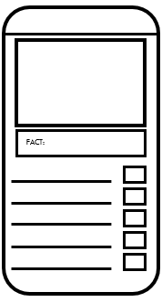 | 2. Draw a story map or comic strip of your story with your good bad character in. | 3. Write a story with your good and bad characters in. Remember the beginning, middle and end.  * 2A’s sentences  * Expanded noun phrases  * Subordinating conjuctions ‘when’ ‘if’ ‘that’ ‘because’ | Look in your garden for signs of Spring. Can you write a Spring poem? Think of daffodils, crocus, colours, lambs, chicks, new buds.
Act out a Fairy Story or your favourite story using teddies and toys as props. Maybe film your production and get family members involved. | Make a poster about what nouns, adjectives, verbs and adverbs are. www.theschoolrun.com | Can you find as many compound words as possible? Write them down or draw some.  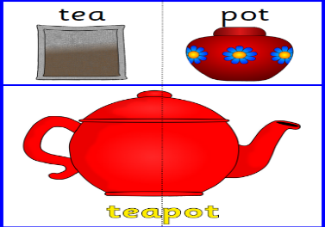 | Can you write some sentences with alliteration in them? Terrible Terence twisted his tongue like a tumbling tube.  