Maths– Place Value and Measures
If the box is coloured blue, then there is a document (see small picture) in this folder that your child can use for the work. They can design their own formats if they would like to.
Tackle the investigations on the Measuring Length challenge cards.  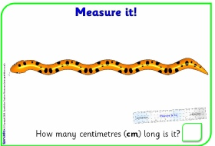 | Measure items around your home using centimetres. Design a format to record these measures.  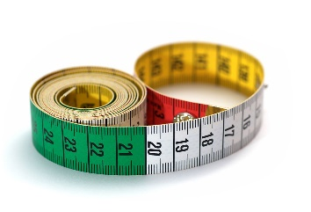 | Complete MyMaths lesson and online homework for:  Year 1 – Comparing measures  Year 2 –Measures | Bake a cake of your choice with a grown up. Cut your cake into half and then quarters to reinforce our learning on fractions.  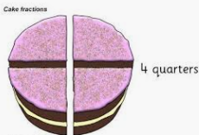
Complete MyMaths lesson and online homework for:  Year 1 – Counting 1  Year 2 –Number and place value  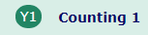  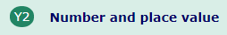 | Use your number skills to complete these ‘Place Value’ tasks.  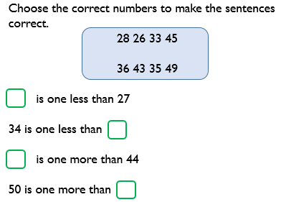 | Go on a shape hunt at home. What 2D and 3D shapes can you see? Design you own format to record the shape you find.  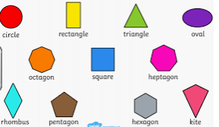 | Play a board game to practise counting on and back to 100  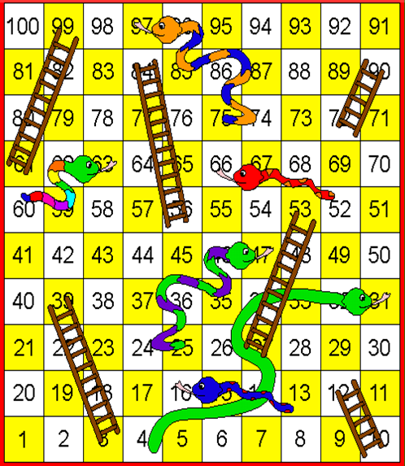
Complete the ‘Measures’ challenges  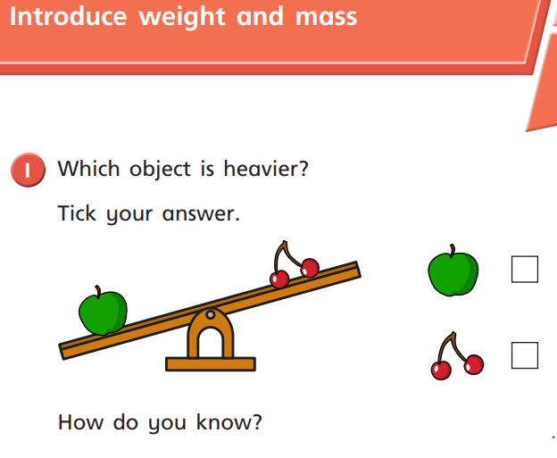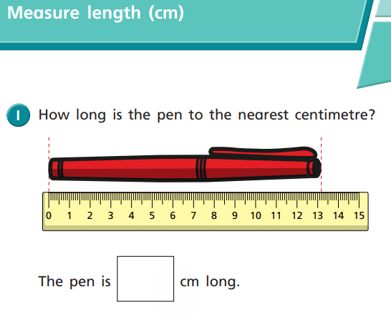 | Continue to practise your tables.  Year 1: 2, 5 and 10  Year 2: 2, 3, 5 and 10  (or your own required tables!)  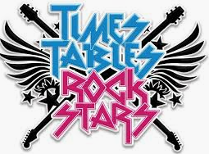 | Complete MyMaths lesson and online homework for:  Year 1 – Comparing mass  Year 2 –Units of measure  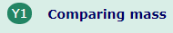 | Use the hundred square to help you fill in the missing numbers.  