KS1 – Theme/Science Activities – Himbleton Time Trekkers | Worcester Cathedral is very famous. The west window has recently been cleaned. Look at a part of the window of the pink giraffe. Could you design a new stained glass window with animal in it? | Edward Elgar is famous. Can you find out about him? Why is he famous? Where did he live in Worcestershire? Did he teach in Worcestershire? Could you find out about his life? Make a Fact File about him. | Can you listen to Edward Elgar’s Nimrod? Discuss this music. How does it make you feel? Do you like it? Could you compose some music? Make an instrument or find something in nature that could make music. Create a family band and record your music.
Can you design an exercise/activity course for you and your family to take part in, in your garden? Have your heart rates risen. Can you time each family member as they run around your course? Is exercise good for you? How does it help our bodies? | Design and make a healthy snack. Why is your snack good for you? Can you photograph it? Imagine you had to sell your snack. What would you call it? Design a label. | This is the Worcestershire Flag. Could you design your own flag for your family?  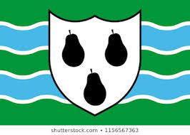 | What are reptiles, mammals, birds, fish and amphibians? Watch bbcbitesize-what is classification?  www.sheppardsoftware.com –animal classification.  Can you find out about 1 animal from each group? Make a top trump card or poster about each animal.
Use Lego /Duplo to build a dream house you would like to live in. What special features does it have? What would surround your house? Can you take a photograph of it? | Worcestershire is famous for its orchards of apples, pears and plums. Make a pie or crumble with any of these fruits. | Design and make a boat to go on the River Severn. Draw your design first and label the boat parts. What will you use to build it? Test it out to see if it will float. | 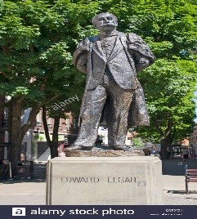  Can you make your own statue? Who will it be of? What will you use to make it?

