Maths and English – Length/Perimeter and Non-Fiction
If the box is coloured blue, then there is a document (see small picture) in this folder that your child can use for the work. They can design their own formats if they would like to.
Tackle the investigations on the Measuring Length challenge cards.  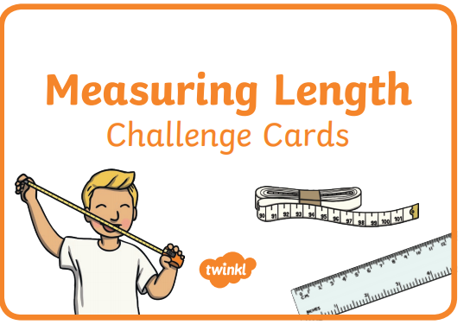 | Measure items around your home. Design a format to record these measures. | Create a mini non-fiction book about your favourite topic. Use the features we have identified.  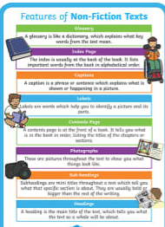 | Complete the noun/pronouns tasks to learn how you can avoid repetition in your writing.  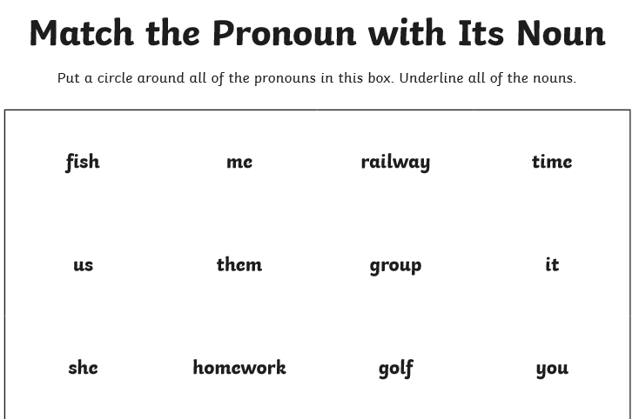
Complete MyMaths lesson and online homework for:  Year 3 – Perimeter  Year 4 – Area  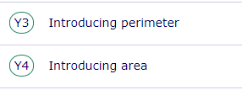 | Use your skills of addition to complete these ‘Adding Lengths’ tasks.  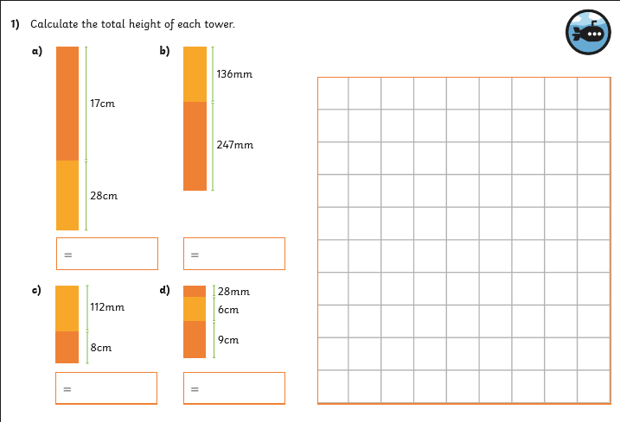 | Practise spelling words with the prefixes super- and auto-.  Use your favourite strategies to practise them.  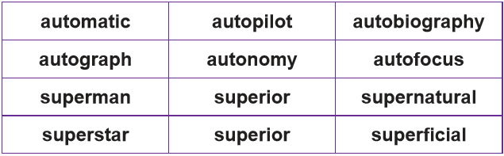 | Write your own Alan Peat description:detail sentences.  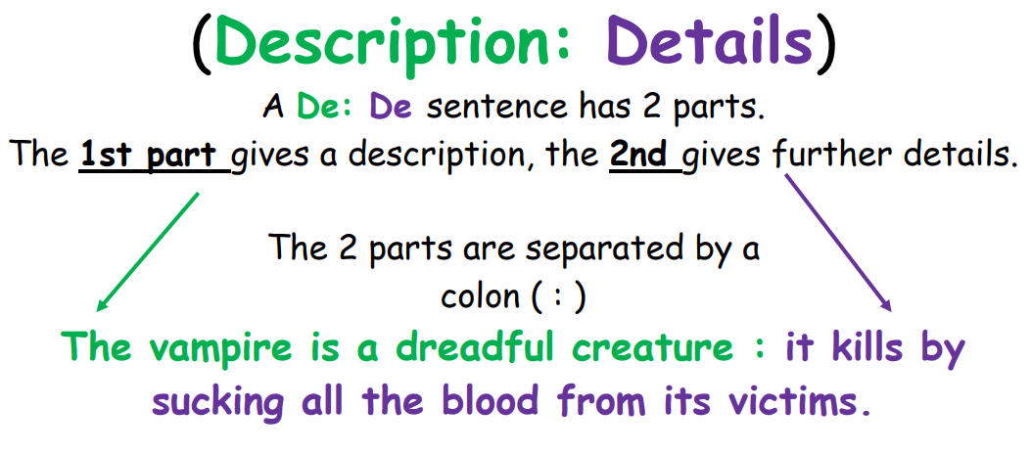
Complete a perimeter investigation into rectilinear shapes.  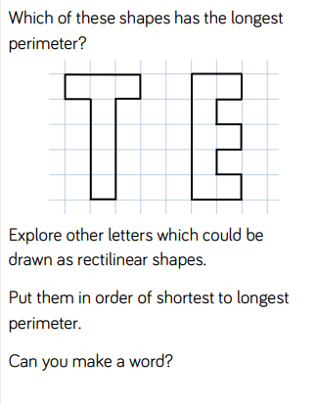 | Continue to practise your tables.  Year 3: 3, 4, and 8  Year 4: 6, 7 and 9  (or your own required tables!) | Sort the words into the correct prefix sacks.  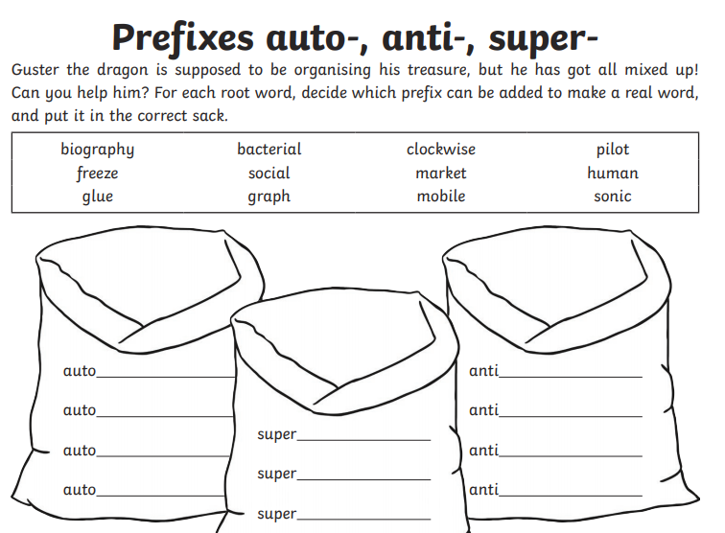 | Read and complete the comprehension tasks based on ‘Red Nose Day’.

