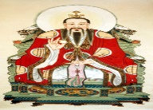
Topic and Science – The Shang Dynasty and Sound
This Photo by Unknown Author is licensed under CC BY-SA
If the box is coloured blue, then there is a document (see small picture) in this folder that your child can use for the work. They can design their own formats if they would like to.
How did Shang craftsmen make items out of bronze, pottery or jade? Write a set of instructions for one of these.  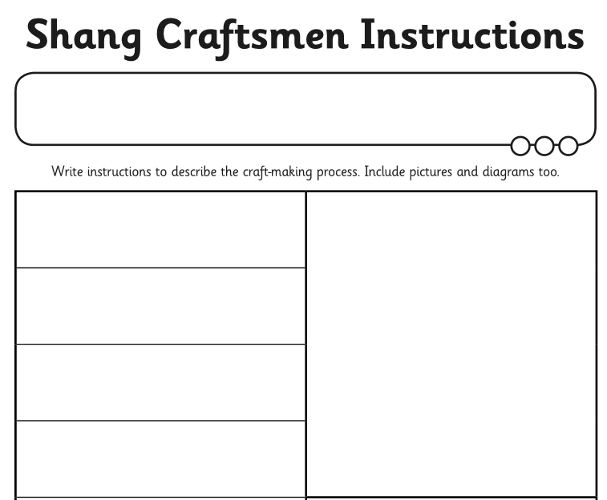 | Make your own dragon/oracle bones.  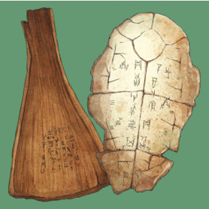 | Design and make a set of ear defenders for a rock band. (Use your knowledge of soundproofing to help you!) | Make your own string telephone.  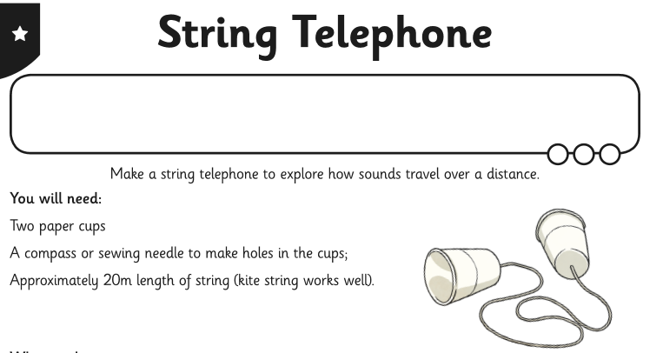
Who was Fu Hao?  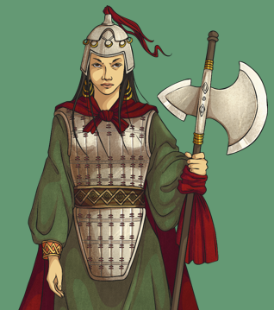  Create a fact file for her. | What can artefacts tell us about Fu Hao? Investigate what was found in her tomb.  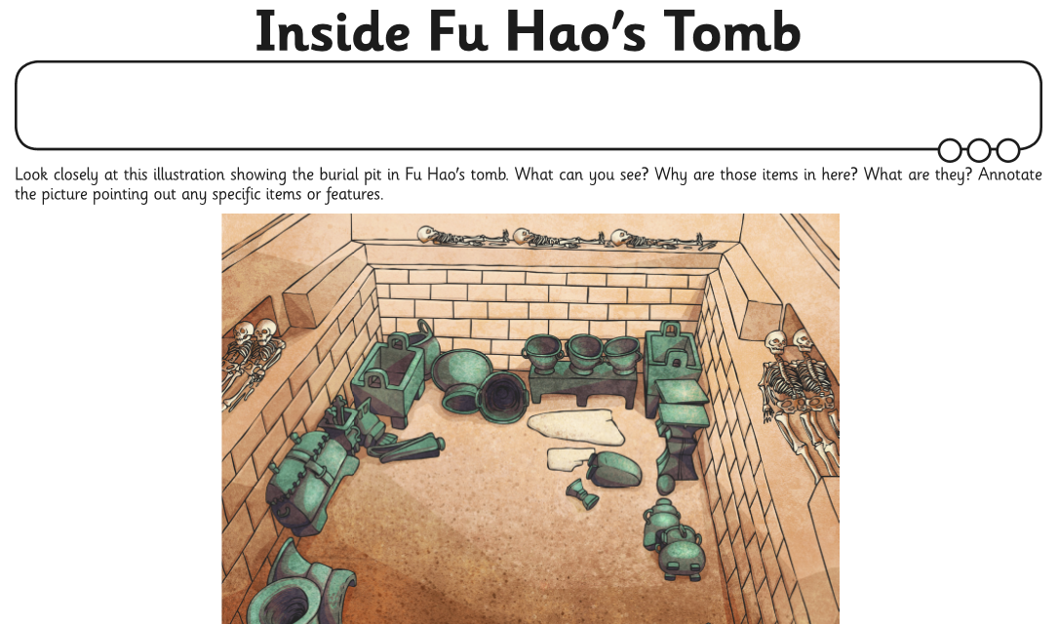 | Practise spelling your name or other words using the British Sign Language alphabet.  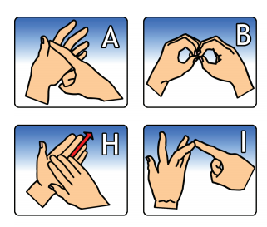 | Plan a short investigation to help you decide which material from a range would be best for muffling a sound.  The activities on this website may be a useful starting point:  http://resources.hwb.wales.gov.uk/VTC/  16022007/sound_travels/lesson.html
Research the battle of Muye. Create a comic strip of the events?  https://www.ks2history.com/battle-of-muye-guide | Why did the Shang Dynasty fall? Imagine you are a Shang fighter. Would you have defected to the other side? Why? Convince me.  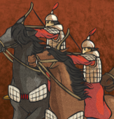 | Play the ‘Good Vibrations’ game to see how much you know about sounds and how we hear them.  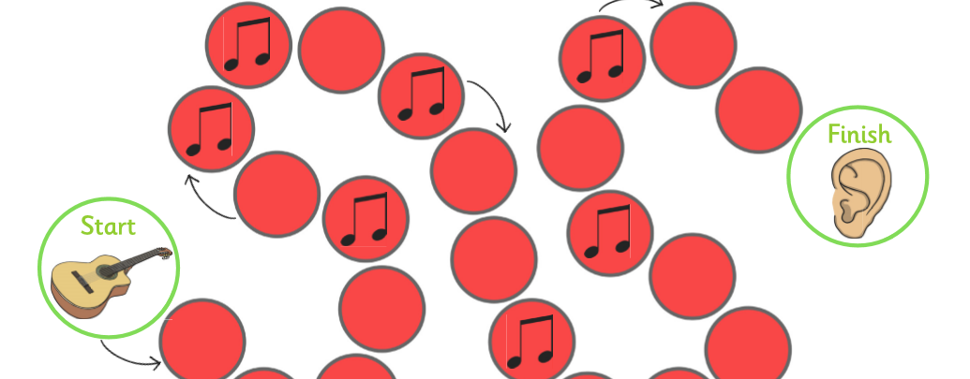 | Carry out a sound survey around your home and garden.  