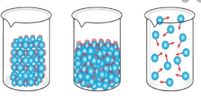
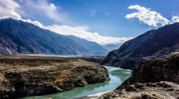
Topic and Science – River Deep, Mountain High and States of Matter
If the box is coloured blue, then there is a document (see small picture) in this folder that your child can use for the work. They can design their own formats if they would like to.
What are the key features of a river? Can you label them correctly on the diagram using the given word bank?  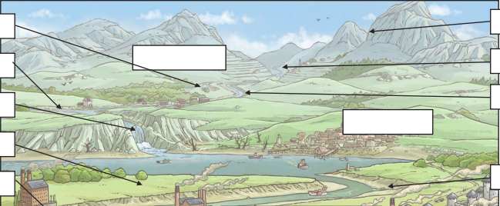 | As an introduction to our new topic, have a look at the BBC website to discover what a river is and how it is formed. https://www.bbc.co.uk/bitesize/ topics/ z849q6f/articles/z7w8pg8  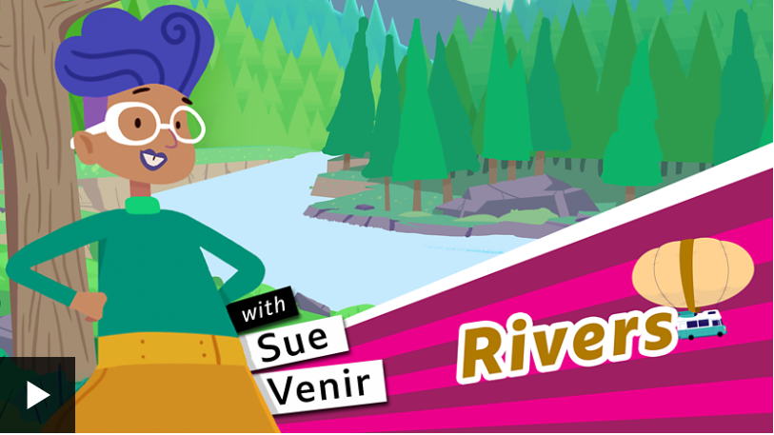 | Explore some of the BBC learning clips to help you find out more about solids, liquids and gases.  https://www.bbc.co.uk/bitesize/ topics/zkgg87h | Sort the objects into the correct categories – are they a solid, a liquid or a gas?  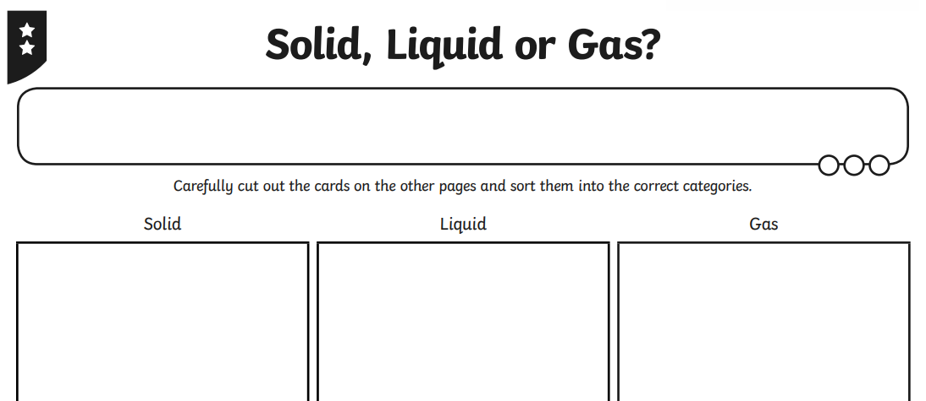
Choose one of the world’s rivers and create a fact file or poster all about it. This could include: where it is located, how long it is, a picture or photograph etc. | Play ‘Rivers Top Trumps’ to discover facts about some of the world’s rivers.  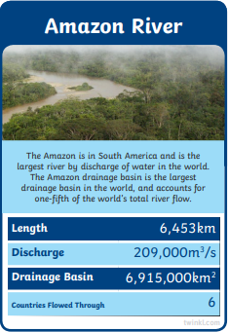 | What is the Water Cycle?  Design a poster or powerpoint to explain this to someone in KS1.  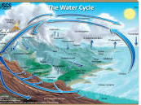 | Plan a short investigation to explore the melting point of 3 familiar materials - ice, chocolate and butter. Think about how you will measure and record your results and how you can make it a fair test.  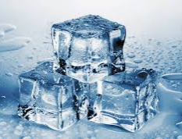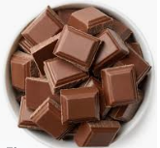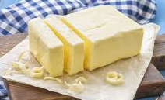
Read all about Rivers and complete the comprehension questions.  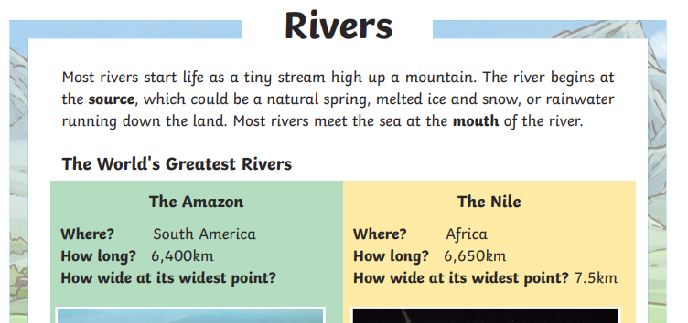 | Make a river model out of things you can find at home. Take a photo!  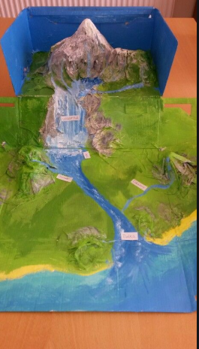 | Use the word bank to help you complete sentences about what happens to solids, liquids and gases.  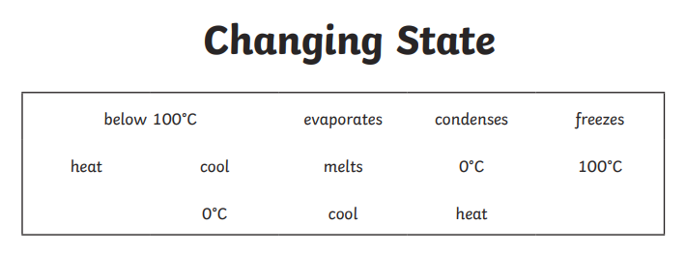 | Play the Water Cycle game to help you learn more about this process.  